**Daily Journal Layout**

**Submitted By**:

* + Team Members- Vora Chanchal

Jana Samyutha M H

Brunda

* + Roll Number 2461037

2461012

2461006

* + College-E-mailid: [vora.chanchal@btech.christuniversity.in](mailto:vora.chanchal@btech.christuniversity.in)

[jana.samyutha@btech.christuniversity.in](mailto:jana.samyutha@btech.christuniversity.in)

brunda@btech.christuniversity.in

* **Course**: FrontEnd UI/UX
* **Instructor Name: Mr. Dhiraj**
* **Institution**: Christ University
* **Date of Submission**: 10/08/2025

**2. Abstract:**

This project involves the design and development of a responsive Daily Journal Website using HTML, CSS, JavaScript, and Bootstrap.   
The platform allows users to log daily entries, track moods, filter/search entries, and switch between light and night modes.   
It includes a password-protected UI (dummy), comment section, and live word count feature.   
The project demonstrates how front-end technologies can be integrated to build an engaging and functional journaling application.

**3. Objectives:**

- Create a responsive and user-friendly journaling website.  
  
- Implement mood tracking with color-coded indicators.  
  
- Enable live word count updates for journal entries.  
  
- Provide password-protected sections (UI simulation).  
  
- Add night mode toggle for better usability.  
  
- Enable search and filter functionalities for easier navigation.  
  
- Allow users to add comments dynamically.

**4. Scope of the Project:**

- Front-end focused, built using HTML, CSS, JavaScript, and Bootstrap.  
  
- Desktop and mobile responsive design.  
  
- No real backend integration, but designed with extendibility in mind.  
  
- Covers UI/UX elements, filtering, interactivity, and styling.

**5. Tools & Technologies Used**

|  |  |
| --- | --- |
| Tool/Technology | Purpose |
| HTML5 | Markup and content structure |
| CSS3 | Styling and layout management |
| VS Code and Notepad | Code editor |
| Chrome DevTools | Testing and debugging |

**6. HTML Structure Overview:**

- Semantic structure with <header>, <main>, <footer>  
  
- Journal grid entries inside Bootstrap card components  
  
- Mood filter dropdown and search bar for filtering content  
  
- Night mode toggle implemented using checkbox + JS  
  
- Comment section for interaction

**7. CSS Styling Strategy:**

- External stylesheet for modularity  
  
- Mood-based color-coded borders using data attributes  
  
- Night mode styling toggled dynamically  
  
- Flexbox and Bootstrap grid used for responsive layouts  
  
- Custom typography with Google Fonts  
  
- Inkblot divider for creative separation  
  
- Blur effect applied for fake password-protected content

**8. Key Features:**

|  |  |
| --- | --- |
| Feature | Description |
| Responsive Layout | |  | | --- | |  |  |  | | --- | | Works smoothly across desktop, tablet, and mobile devices using Bootstrap grid & custom CSS. | |
| Mood Indicator System | |  | | --- | |  |  |  | | --- | | Entries highlighted with mood-based color borders (Happy, Sad, Excited, Tired, Neutral). | |
| Live Word Count | Automatically updates as the user types in a journal entry |
| Fake Password Protection | Sections blurred and locked with dummy password input (UI simulation). |
| Night Mode Toggle | Switches between light and dark themes for better readability. |
| Search & Filter | Users can search entries or filter by mood for easy navigation. |
| Comments Section | |  | | --- | |  |  |  | | --- | | Allows adding comments dynamically under each journal entry. | |

**9. Challenges Faced & Solutions:**

|  |  |
| --- | --- |
| Challenge | Solution |
| Managing dynamic content like comments | Used jQuery event handling to add/remove comments efficiently. |
| Responsive design breaking on small screens | Applied Bootstrap grid + custom media queries for layout adjustments. |
| Mood selection not updating visually | |  | | --- | |  |  |  | | --- | | Bound JavaScript to update data-mood attribute dynamically. | |
| Word count not updating properly | Implemented JavaScript input listener with regex filtering for accuracy. |
| UI overlap in night mode toggle | |  | | --- | |  |  |  | | --- | | Adjusted CSS class toggling for body, header, footer, and card elements. | |

**10. Outcome:**

- Successfully developed a functional Daily Journal website.  
  
- Integrated HTML, CSS, Bootstrap, and JavaScript features seamlessly.  
  
- Improved knowledge in UI/UX design, interactivity, and responsiveness.  
  
- Created a creative, interactive journaling platform for daily use.

**11. Future Enhancement:**

- Backend integration for saving journal entries.  
  
- User authentication and real password protection.  
  
- Cloud storage for long-term journaling.  
  
- Adding animations and smooth transitions.  
  
- Export journal entries as PDF or Word.  
  
- Multi-user support.

**12. Sample Code:**

**Word Count Functionality**

// Live Word Count

$("#entry-text").on("input", function () {

let words = $(this).val().trim().split(/\s+/).filter(w => w.length > 0);

$("#word-count").text(words.length);

}).trigger("input");

**Mood Change (Dynamic Border Color)**

// Change mood dynamically

$("#mood-select").change(function () {

$(this).closest(".journal-entry").attr("data-mood", $(this).val());

});

**Unlock Fake Password Section**

// Fake password unlock

$(".unlock-btn").click(function () {

$(this).closest(".fake-password").next(".locked")

.removeClass("locked")

.hide()

.fadeIn(600);

});

**Add Comment Feature**

// Add comment dynamically

$("#add-comment").click(function () {

let text = $("#comment-input").val().trim();

if (text) {

$(".comments").append(`<div class="comment p-2 border rounded mt-1">${text}</div>`);

$("#comment-input").val("");

}

});

**Night Mode Toggle**

// Night mode toggle

$("#night-toggle").change(function () {

$("body").toggleClass("bg-dark text-light");

$(".card").toggleClass("bg-secondary text-light");

$("footer, header").toggleClass("bg-dark text-light");

});

**Search + Filter Functionality**

// Search + Filter

function filterEntries() {

let search = $("#search-input").val().toLowerCase();

let mood = $("#filter-mood").val();

$(".journal-entry").each(function () {

let text = $(this).text().toLowerCase();

let entryMood = $(this).data("mood");

let matchesSearch = text.includes(search);

let matchesMood = (mood === "all" || mood === entryMood);

if (matchesSearch && matchesMood) $(this).fadeIn(300);

else $(this).fadeOut(300);

});

}

$("#search-input, #filter-mood").on("input change", filterEntries);

// Reset filters

$("#clear-filters").click(function () {

$("#search-input").val("");

$("#filter-mood").val("all");

filterEntries();

});

**CSS Mood Border Colors**

/* Mood-based border colors */

.journal-entry[data-mood="happy"] { border-color: #4caf50; }

.journal-entry[data-mood="sad"] { border-color: #2196f3; }

.journal-entry[data-mood="excited"] { border-color: #f44336; }

.journal-entry[data-mood="tired"] { border-color: #795548; }

.journal-entry[data-mood="neutral"] { border-color: #9e9e9e; }

**13. Screenshots of Final Output:**

**Desktop:**

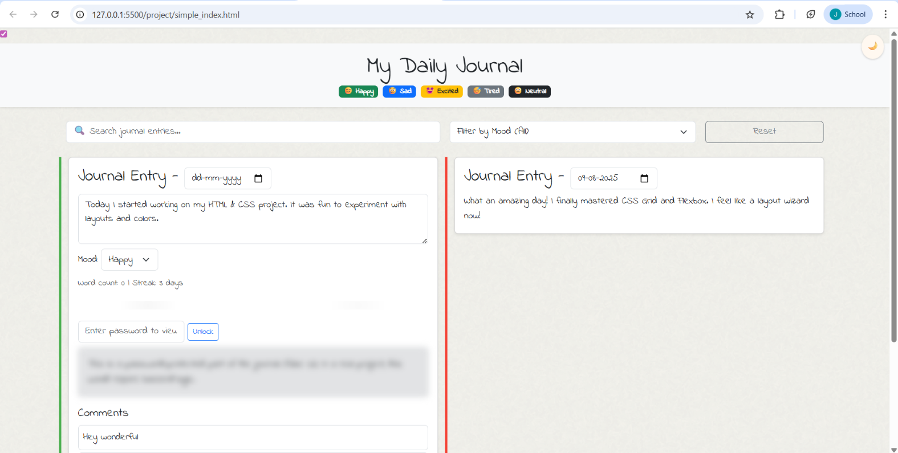

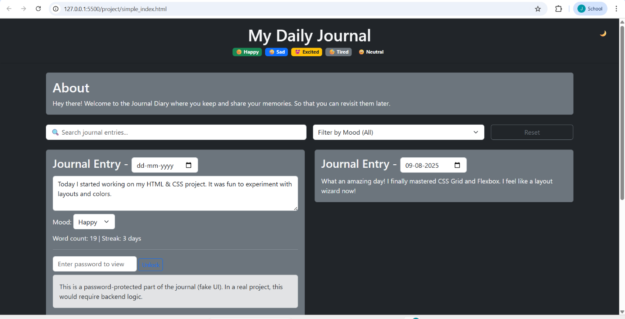

**11. Conclusion**

This project successfully demonstrates how HTML, CSS, Bootstrap, and JavaScript can be combined to create a dynamic, user-friendly Daily Journal platform.   
It showcases skills in responsive design, UI styling, and interactivity.   
Future improvements can make it a fully functional web application with backend storage and authentication.

**12. References**

- L&T LMS: https://learn.lntedutech.com/Landing/MyCourse  
  
- Bootstrap Documentation: https://getbootstrap.com/  
  
- jQuery Documentation: https://jquery.com/  
  
- Google Fonts: https://fonts.google.com/